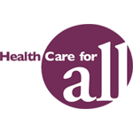 FOR THE PEOPLE -- 2014

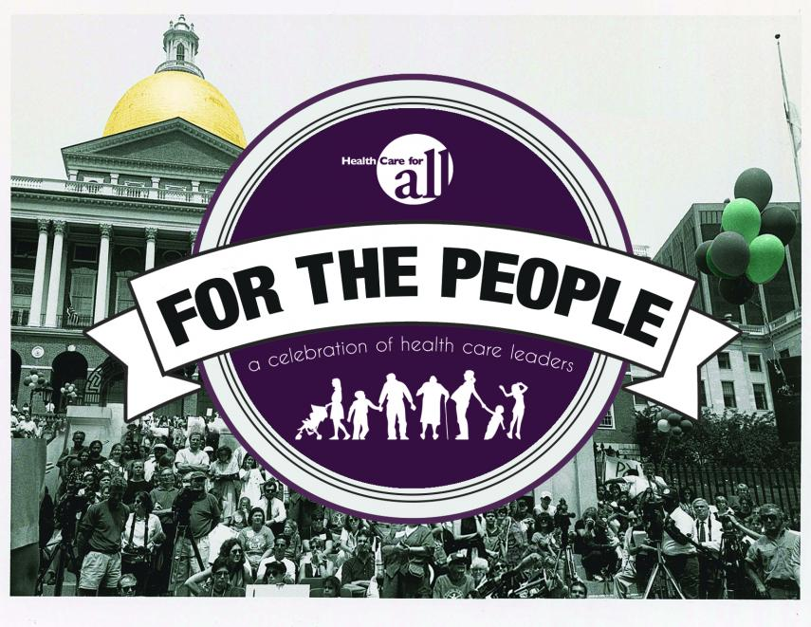
Honoring Nick Littlefield, Retired Partner at Foley Hoag LLP
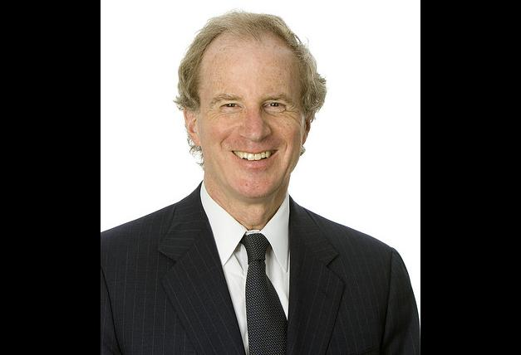
Join us to honor Nick Littlefield at our annual event "For The People: A Celebration of Health Care Leaders", on Wednesday, April 2nd from 5:30-8:30PM at the Westin Copley Place Boston Hotel. Click here for more information.
Health Care For All's annual event, For The People: A Celebration of Health Care Leaders will be Wednesday, April 2nd from 5:30 PM - 8:30 PM at the Westin Copley Place Boston Hotel. https://www.hcfama.org/

Tickets:
Members: $150.00
Non-members: $250.00
For tickets, purchase here or contact Melissa Freitas at 617-275-2926 or email freitas@hcfama.org.

2014 Leadership Award Recipients

Governor Deval L. Patrick
Commonwealth of Massachusetts

Nick Littlefield
Retired Partner
Foley Hoag LLP

Secretary Glen Shor
Executive Office for Administration and Finance
Commonwealth of Massachusetts

2014 John Auerbach Community Leader Award Recipient

Community Action of the Franklin, Hampshire, and the North Quabbin Regions
Join us as we honor health care leaders from across the Commonwealth and raise general operating support for our organization to continue our work advocating for a consumer centered health care system. The event includes networking, dinner, and a short program recognizing our honorees and highlighting the voices of Massachusetts health care consumers.
Event Agenda
5:30 PM
Registration & Networking
6:15 PM
Dinner
6:45 PM
Program
8:00 PM
Dessert & Networking

